NAME: MAX FELBERG

RESEARCH QUESTION WORKSHEET
Complete this worksheet to the best of your ability; answers do not need to be complete sentences unless specifically stated.

Part 1: ANOVA question
- State your question as clearly and specifically as possible.

How does seedling health (transpiration, greenness) differ by treatment type and by block? Does the dead tree treatment specifically lead to better or worse seedling health? And is there an overarching spatial gradient in health along blocks?

- State your null and alternative hypotheses.

Alternative: Seedling transpiration and greenness is impacted by the presence of nearby decomposition and varies spatially.
Null: Seedling transpiration and greenness is not impacted by the presence of nearby decomposition and does not vary spatially.

- What are the variables you plan to analyze? State whether each is categorical or continuous. For categorical variables, list all the levels for each. For continuous variables, write the unit of measurement (e.g., cm).

 | Variable Name | Categorical/Continuous | Levels/Units
Predictors | Treatment Type | Categorical | Open Space, Dead Tree, Adult Canopy, Natural Recruit
 | Block | Categorical | 1-8 – but they need to be divided into groups of 1-4 and 5-8 because of rainstorm between collection dates
Response | Greenness | Continuous | SPAD
 | Transpiration | Continuous | mmol m^-2 s^-1 (micromoles of water per square meter of leaf area per second)

- Which data file do you plan to use? What are the relevant columns of your data frame?
SPAD file columns: Date, Block, Treatment, Tag_Num, Leaf1, Leaf2, Leaf3, Leaf4, Leaf5, Leaf6
LICORE file columns: Date, Block, Treatment, Tag number, PORO E_apparent

- Compare the data frame to your variable table. Are your variables in the data format/units you need them to be in order to analyze them? (i.e., do you need to summarize counts, ratios, etc.) If not, describe which need to be modified and how.

- SPAD values will need to be averaged across rows in order to have a single value for each seedling
- LICOR transpiration values need to be converted from character to numerical
- Treatment needs to be converted to factor type, maybe blocks too
- Dates in both datafiles need to be converted to date datatype, just to be consistent

- Do you need to filter the dataset for only data that apply to a certain treatment, plant species etc.? List the conditions you will filter for.

- Filter for dead tree, open space, and natural recruits. I’m going to look at the adult canopy treatment to see if there’s anything interesting, but I think OS and DT offer good dramatic contrast, and natural recruits serve as a bit of control.
- I’ll also have to divide blocks by date, since blocks 5-8 were measured after a rainstorm, which will impact the data.

- Write the formula for your analysis. (i.e., height ~ length, or growth ~ location * water)

Transpiration ~ treatment * block
Greenness ~ treatment * block

- What will you write about in your discussion section about what the results mean if the null hypothesis is rejected?

- Overall benefits of being positioned nearby decomposition
- How decomposition impacts the nutrient cycle and nearby plants being impacted by these beneficial changes first
- Can include:
  - Animals and invertebrates involved in the process plus potential pollination and pest control
  - Mycorrhizal relationships
  - Bacteria
- For any spatial differences I’d have to look into some possible differences between blocks like elevation or proximity to roads, then discuss how this may impact seedlings via pollution or water flow along slopes
- How transpiration and greenness changes in response to nutrient availability

- If the null hypothesis is NOT rejected?
- Other factors that may be impacting seedling health that are not related to any of the treatments, so things other than nearby nutrient changes, shade / other impacts from adult canopy, ample space and a lot of sunshine for open space
- Drawbacks of being positioned near decomposition
- If there’s a difference between wet and dry blocks- how the decomposition process may have changed under more wet or near-anaerobic conditions

- What statistics should you report for your test?
- Degrees of freedom
- P values for each interaction
- Mean, standard deviation, standard error
- Tukey test!

- What kind of plot will best display your results? Draw/paste a mock-up of what you want your plot to look like, labeling axes. (photos of hand-drawn figures encouraged)

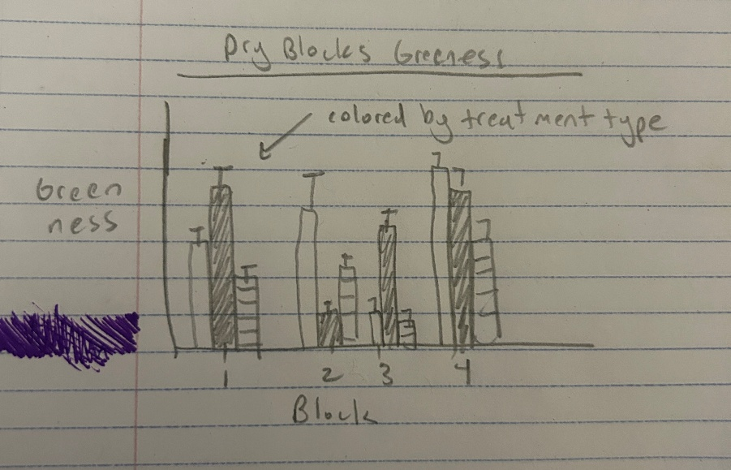 + a similar one for transpiration and the wet blocks, could also do a table of any cool significant pairs.

Part 2: Regression Analysis

- State your question as clearly and specifically as possible.

What is the relationship between seedling transpiration and soil moisture? Is there any difference between treatment types? (I could also see how it varies by date- dry/wet observations…)

- State your null and alternative hypotheses.
Null: There is no relationship or correlation between soil moisture and transpiration. Treatment types show no difference.

Alternative: There is a relationship or correlation between soil moisture and transpiration. Treatment types do show a difference in relationships.

- What are the variables you plan to analyze? State whether each is categorical or continuous. For categorical variables, list all the levels for each. For continuous variables, write the unit of measurement (e.g., cm).

 | Variable Name | Categorical/Continuous | Levels/Units
Predictors | Treatment type | Categorical | Open Space, Dead Tree, Adult Canopy, Natural Recruit
 | Soil Moisture | continuous | percentage
Response | Transpiration | Continuous | mmol m^-2 s^-1 (micromoles of water per square meter of leaf area per second)

- Which data file do you plan to use? What are the relevant columns of your data frame?
LICOR and Soil Moisture files
LICOR: Date, Block, Treatment, Tag number, PORO E_apparent
Soil Moisture: Date, Block, Treatment, Tag number, VWC1, VWC2, VWC3

- Compare the data frame to your variable table. Are your variables in the data format/units you need them to be in order to analyze them? (i.e., do you need to summarize counts, ratios, etc.) If not, describe which need to be modified and how.

- LICOR values need to be converted into numerical data type
- Certain columns from soil moisture need to be dropped

- Which statistical test do you plan to use?
- Regression + residual plot and qq plot assessments?
- T tests between treatment types, show difference in mean soil moisture and transpiration

- Write the formula for your analysis. (i.e., height ~ length, or growth ~ location * water)
- Transpiration ~ soil moisture

- What will you write about in your discussion section about what the results mean if the null hypothesis is rejected?

- How transpiration and soil moisture is related to each other, probably how plants change and adapt their strategies to their environmental conditions- especially if there’s a good difference between wet/dry observations
- How treatment type might have impacted soil moisture, does the nearby adult canopy lead to better percolation due to its roots? Were any of the seedlings protected and show lower moisture values? Did the open space treatment lead to more runoff instead of percolation?

- If the null hypothesis is NOT rejected?
- I’d have to see the relationships first to really decide what to write about and what might be going on…
- Possible effects from treatment types that may make an overall relationship unclear
- Specific factors of oak life history that might be behind this? Maybe specific environmental factors of the area?

- What statistics should you report for your test?
- R squared
- Slope of linear relationship
- Pvalues for t tests

- What kind of plot will best display your results? Draw a mock-up of what you want your plot to look like, labeling axes. (photos of hand-drawn figures encouraged)

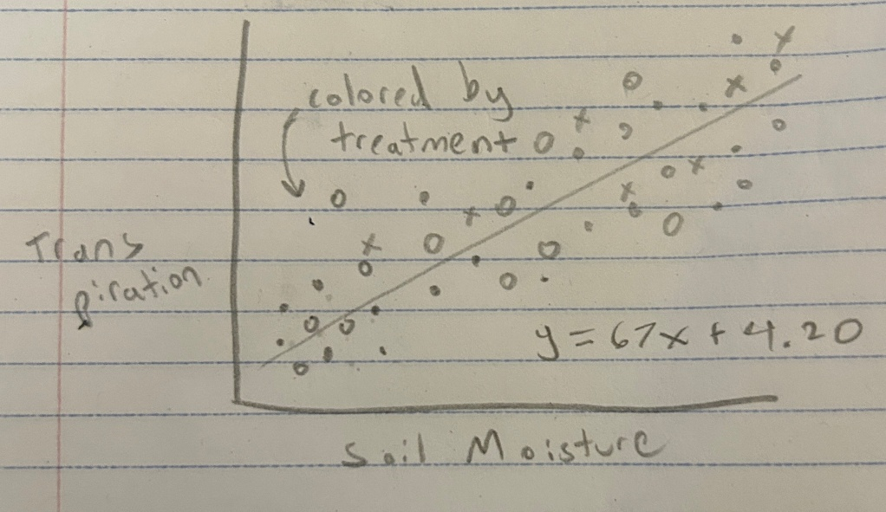 can also be divided into separate graphs based on treatment type to see relationships in each group on their own

